# Records to Script

Use of the tool:

This tool could be used for generating the script for test class records.  
This tool could also be used to replicate higher environments record to lower environments to investigate the issue.

Please find below screenshot to use the tool:

1. Login Page (OAuth is not enabled for now)

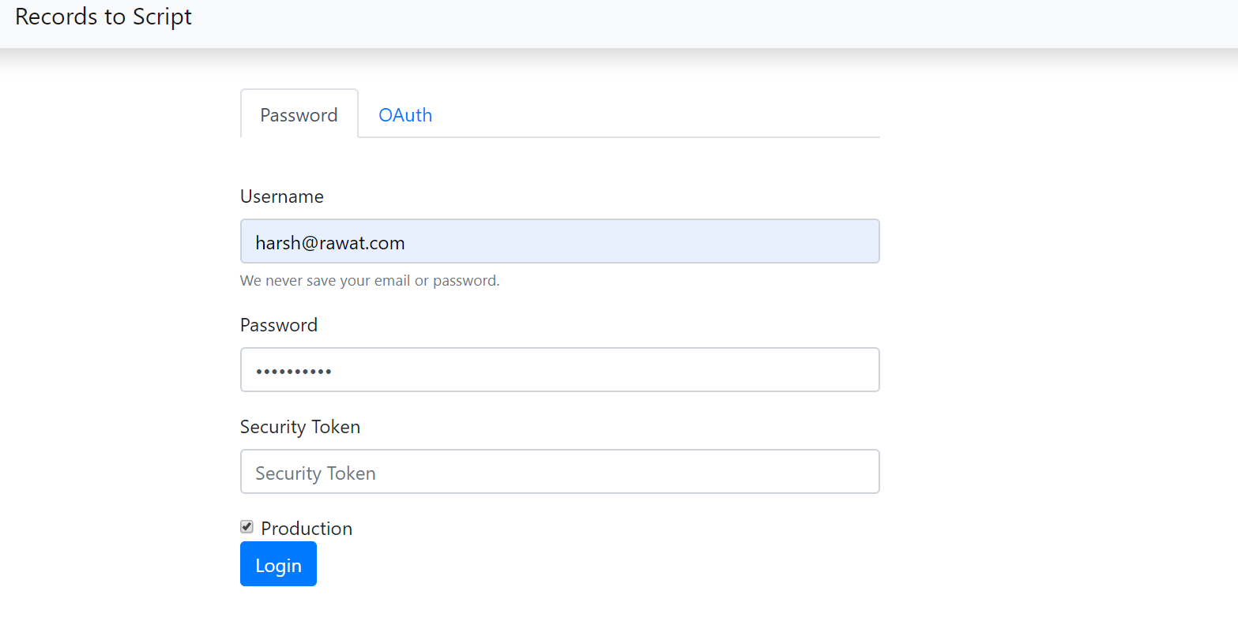

1. Record Id (Enhancing to SOQL)

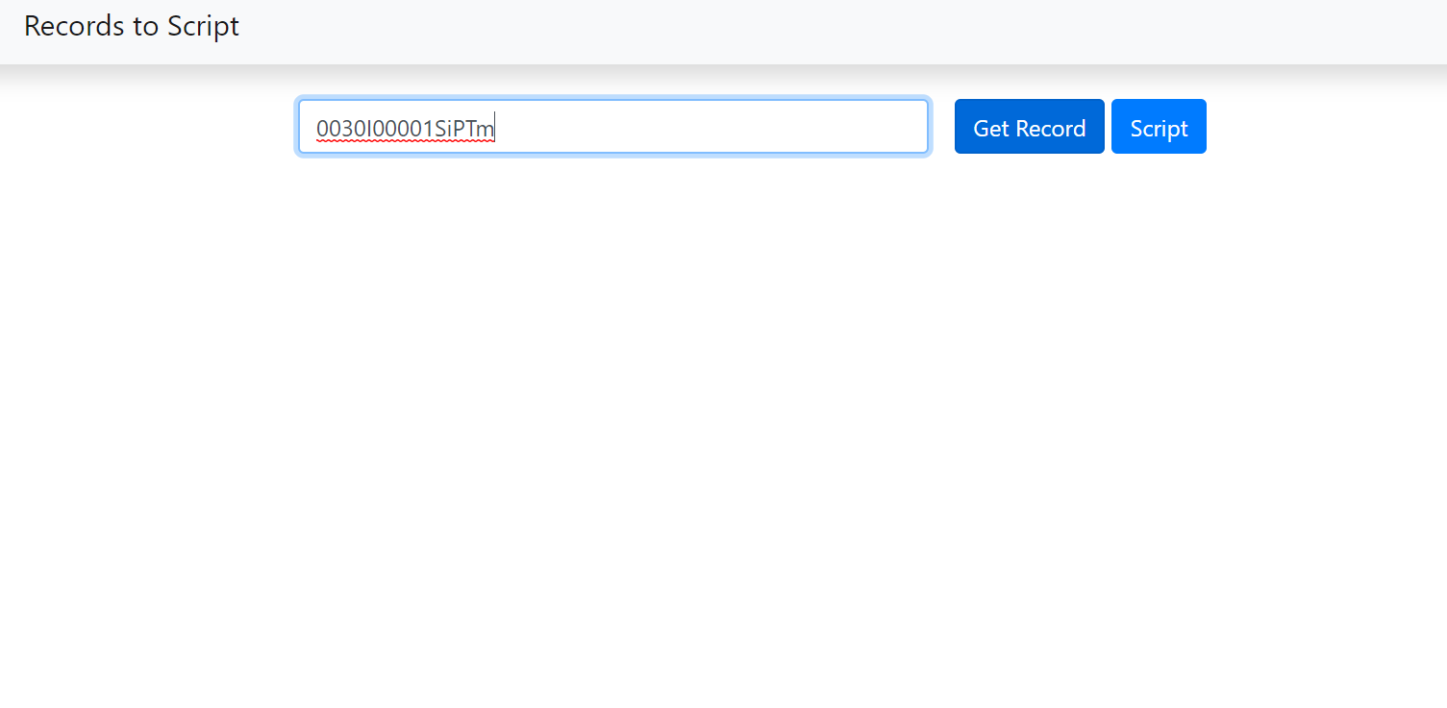

1. Get Record (Tool will travers all records upwards and trace all parent connections)

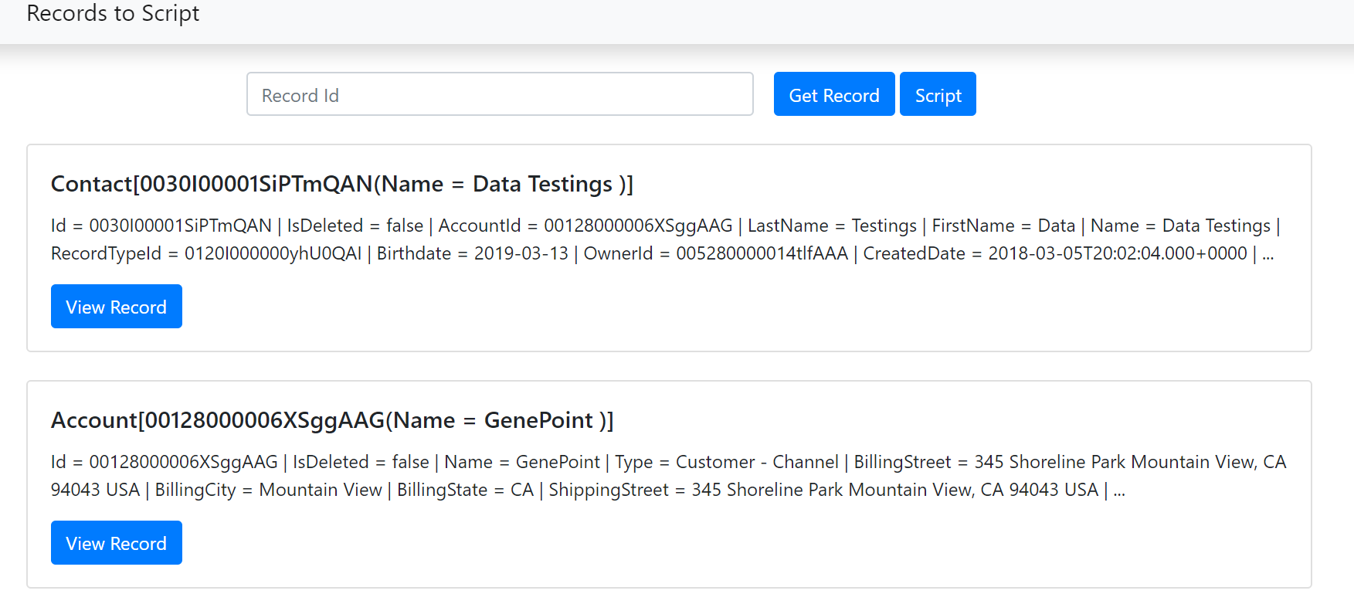

1. Click on Script (Script will be created for all the record with parent connection.)

